user@user-OptiPlex-7040:~$ cd Documents
user@user-OptiPlex-7040:~/Documents$ mkdir lab3
user@user-OptiPlex-7040:~/Documents$ ls
lab3 Maju
user@user-OptiPlex-7040:~/Documents$ cd lab3
user@user-OptiPlex-7040:~/Documents/lab3$ gedit
user@user-OptiPlex-7040:~/Documents/lab3$ chmod -r python
user@user-OptiPlex-7040:~/Documents/lab3$ cat python
cat: python: Permission denied
user@user-OptiPlex-7040:~/Documents/lab3$ chmod +r python
user@user-OptiPlex-7040:~/Documents/lab3$ cat python
print "Hi,This is Os lab"
user@user-OptiPlex-7040:~/Documents/lab3$ cd
user@user-OptiPlex-7040:~$ ^C
user@user-OptiPlex-7040:~$ cd Downloads
user@user-OptiPlex-7040:~/Downloads$ cd lab3
bash: cd: lab3: No such file or directory
user@user-OptiPlex-7040:~/Downloads$ ls
user@user-OptiPlex-7040:~/Downloads$ mkdir lab03
user@user-OptiPlex-7040:~/Downloads$ ls
lab03
user@user-OptiPlex-7040:~/Downloads$ gedit
user@user-OptiPlex-7040:~/Downloads$ chmod -w task
user@user-OptiPlex-7040:~/Downloads$ cat task
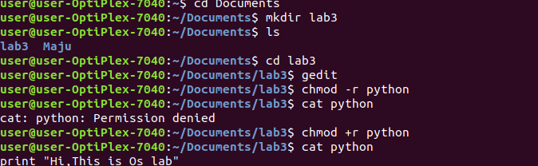
enter ur password:

